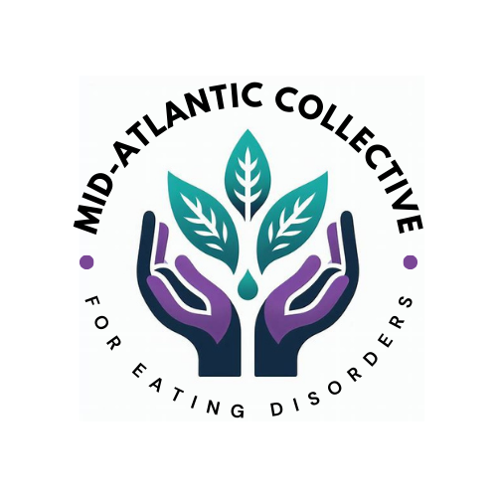

**2024 Sponsorship Opportunities**

We are introducing a new organization, the Mid-Atlantic Collective for Eating Disorders (MAC) and offering founding sponsorships for 2024.

***Our Mission:***

*To cultivate an inclusive eating disorders healing community to foster continual growth and learning.*

***Our Values:***

*In pursuit of our mission, we will raise awareness and educate our community. We will encourage an inclusive community that values lived experience. We will advocate for equitable treatment and access to care. We will promote evidence-informed care through a harm reductionist lens.*

*We envision a community in which members continue to learn in the best interest of those with eating disorders and their loved ones.*

We have two sponsorship levels - $1500 and $150 (for private-practice)  
  
Founding sponsors at the $1500 level will be invited to attend and exhibit at our pop-up networking events that will be held in various mid-atlantic states between now and the end of the year. Dates and locations will be announced shortly.

A completed form with payment will secure your spot.   
Please submit the payment and the form by October 31, 2024 to be listed as a founding sponsor.

Questions? Contact us at [macforeatingdisorders@gmail.com](mailto:macforeatingdisorders@gmail.com)

**Sponsor Donation Form 2024**

**Sponsor level selected (circle one):**

**Founding sponsor: $1500**

**Founding sponsor (private practice): $150**

**Sponsor Information (Print or Type)   
  
$1500 sponsors**: Please send your logo (preferably on a transparent background) to [macforeatingdisorders@gmail.com](mailto:macforeatingdisorders@gmail.com)  
  
**Private practice sponsors**: Please send the link to your practice or we will use your email address to link to the name of your practice.

|  |  |
| --- | --- |
| Company Name |  |
| Contact Name |  |
| Address 1 |  |
| Address 2 |  |
| City, State, Zip |  |
| Phone |  |
| Email |  |

**Payment:**

1. Fill out the form and return via email. We will then send you an invoice from Paypal which will allow you to pay via credit card.
2. OR, make your check payable to “Mid-Atlantic Collective for Eating Disorders” and send the check and completed form to the address below.

**MAC for EDs**

**637 Emerson Place**

**Severna Park, MD 21146**

**Thank you for your sponsorship and continuous support!**